Running using Docker
from terminal
docker compose build
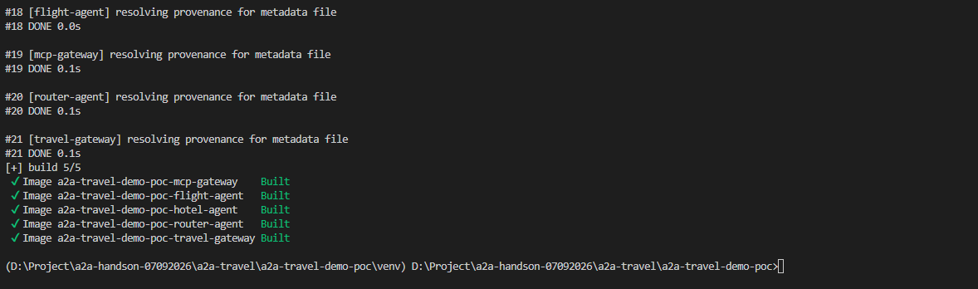
You can also validate the Compose configuration first:
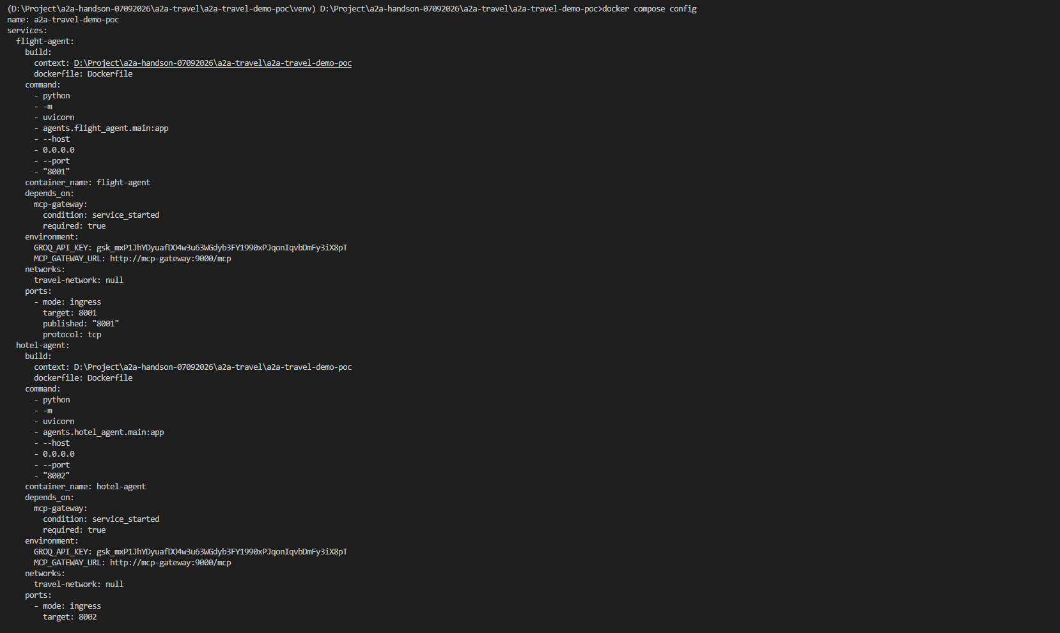
Start everything
docker compose up
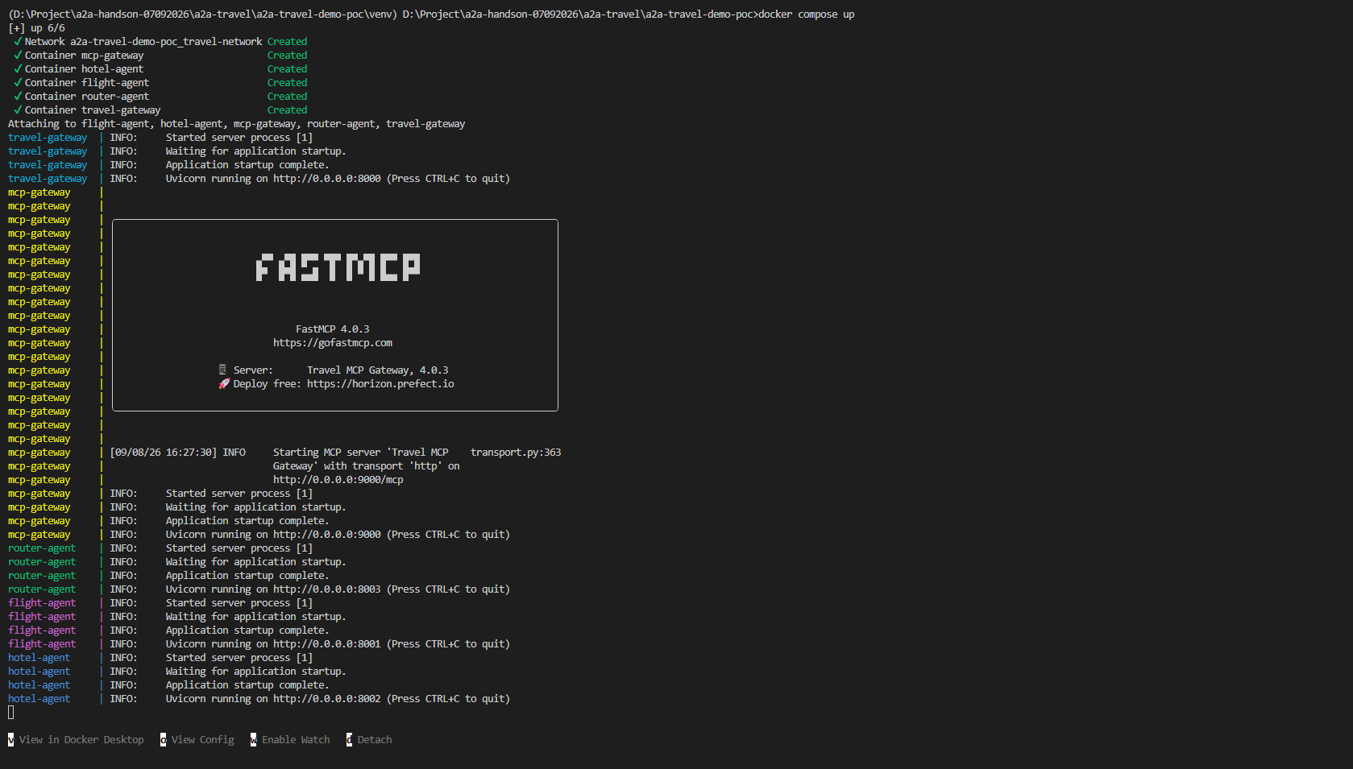
Docker compose ps
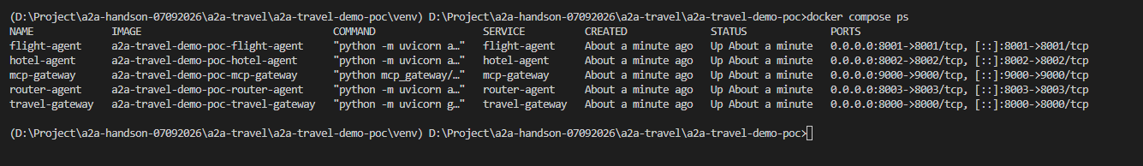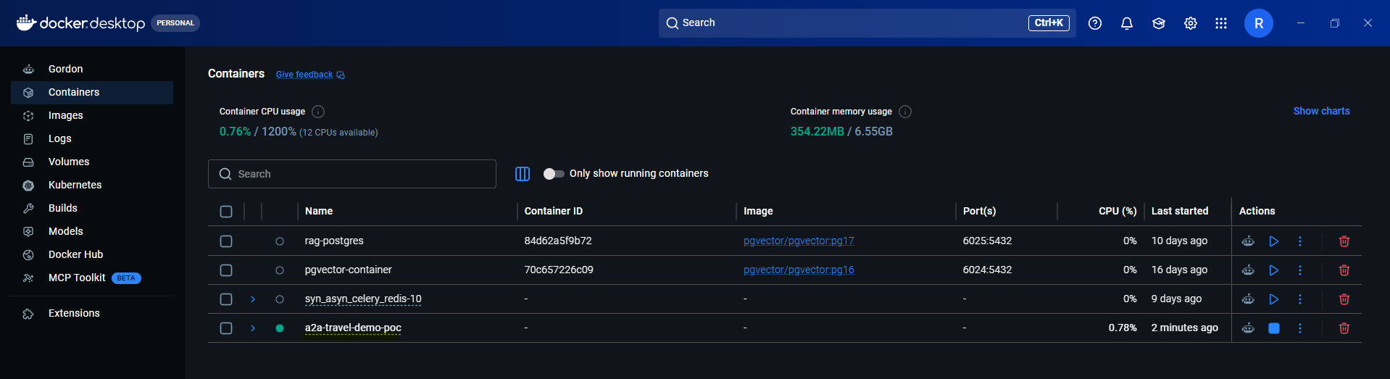
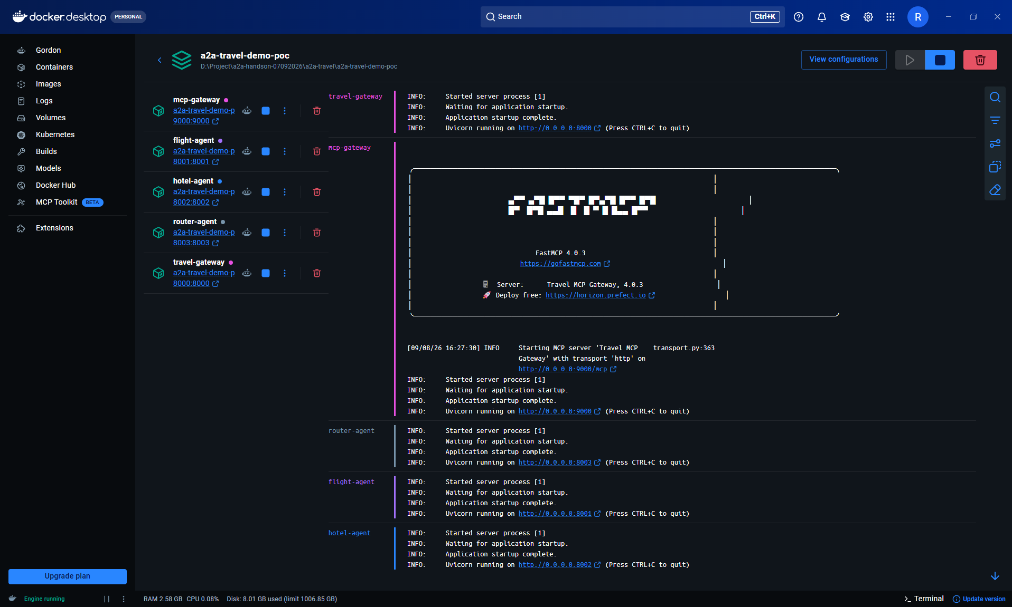

Test the MCP Gateway
from another terminal run python -m tests.check_mcp_tools
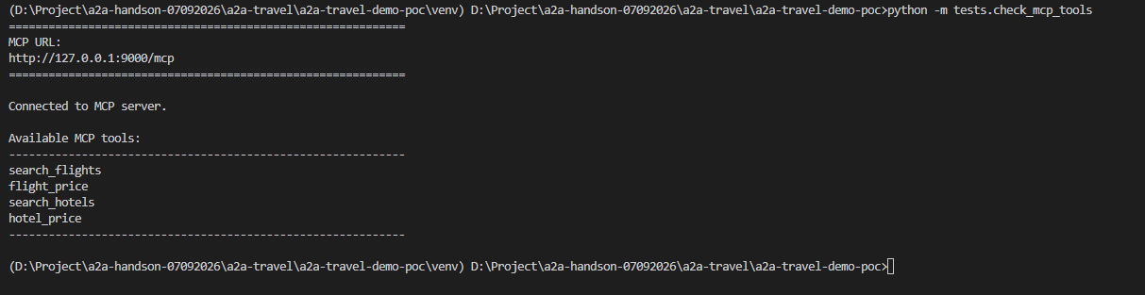
Test Flight Agent
Run curl http://127.0.0.1:8001/health
Test Hotel Agent
curl http://127.0.0.1:8002/health

Test the complete system
python -m tests.test_agent
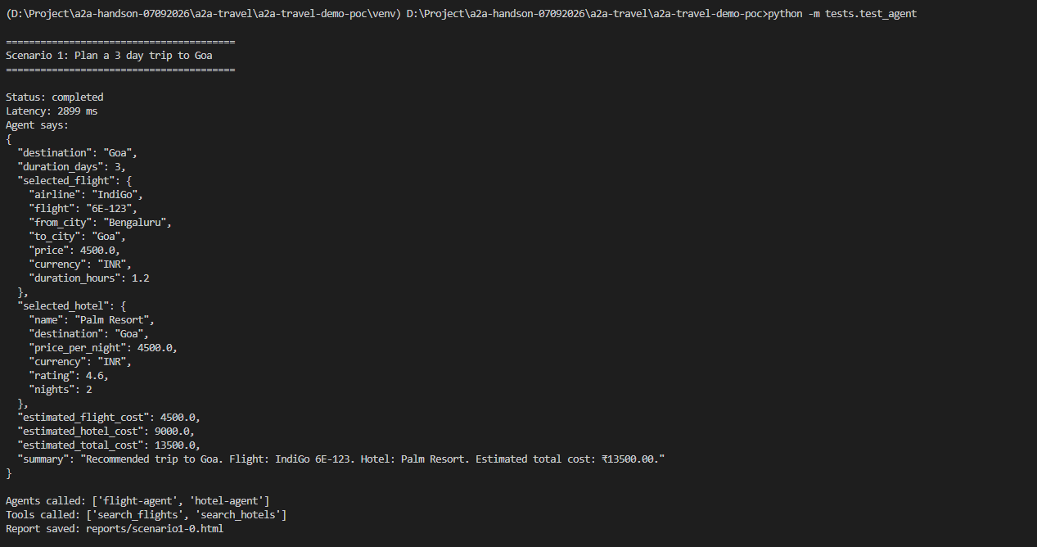

Once you move to Docker Compose, don't use your run_all.py to start the services.
Instead docker compose up becomes your new run_all.

Make Sure To stop everything:
docker compose down
